1. Create a “Deloitte” User using SQL PLUS.
2. Change the password of “Deloitte” user to new password.
3. 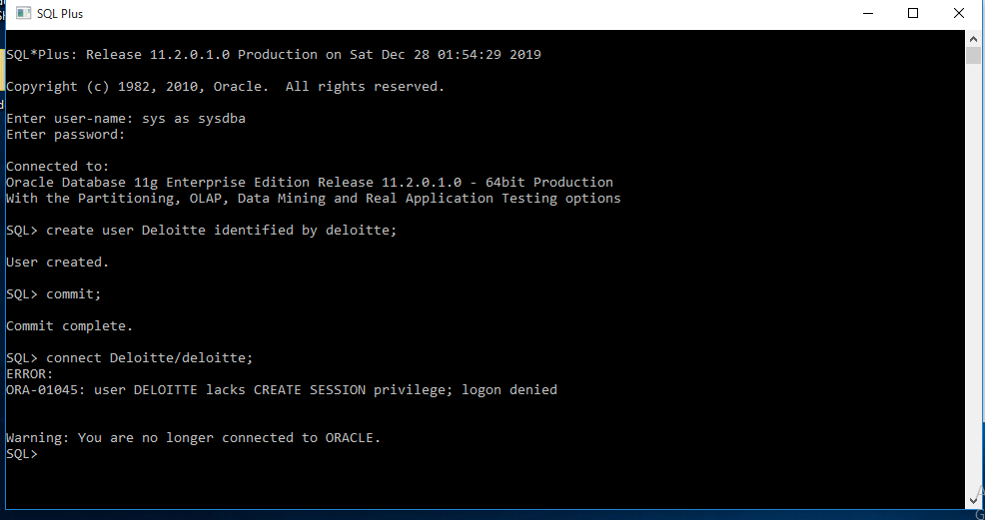Create a schema in the “Deloitte” user using Worker.sql, Bonus.sql and Title.sql file in SQL Developer.

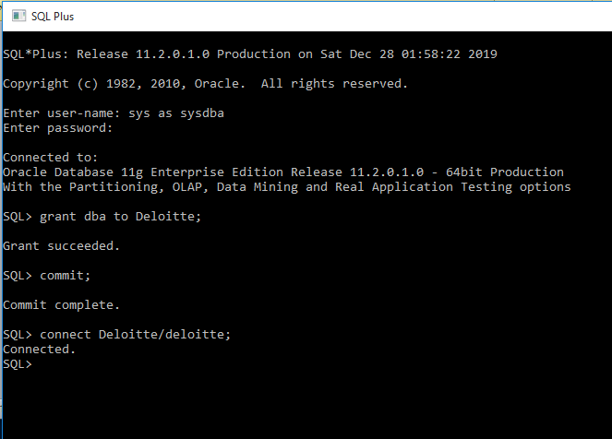

--4. Write An SQL Query To Fetch “FIRST_NAME” From Worker Table Using The Alias Name As <WORKER_NAME>.

SELECT FIRST_NAME AS WORKER_NAME

FROM WORKER;

--5. Write An SQL Query To Fetch “FIRST_NAME” From Worker Table In Upper Case.

SELECT UPPER(FIRST_NAME)

FROM WORKER;

--6. Write An SQL Query To Fetch Unique Values Of DEPARTMENT From Worker Table.

SELECT DISTINCT DEPARTMENT

FROM WORKER;

--7. Write An SQL Query To Find The Position Of The Alphabet (‘A’) In The First Name Column ‘Amitabh’ From Worker Table.

SELECT INSTR(FIRST_NAME, 'A')

FROM WORKER;

--8. Write An SQL Query To Print The First Three Characters Of FIRST_NAME From Worker Table.

SELECT SUBSTR(FIRST_NAME, 1,3)

FROM WORKER;

--9. Write An SQL Query To Print The FIRST_NAME From Worker Table After Removing White Spaces From The Right Side.

SELECT RTRIM(FIRST_NAME)

FROM WORKER;

--10. Write An SQL Query To Print The DEPARTMENT From Worker Table After Removing White Spaces From The Left Side.

SELECT LTRIM(DEPARTMENT)

FROM WORKER;

--11. Write An SQL Query That Fetches The Unique Values Of DEPARTMENT From Worker Table And Prints Its Length.

SELECT DISTINCT DEPARTMENT, LENGTH(RTRIM(DEPARTMENT))

FROM WORKER;

--12. Write An SQL Query To Print The FIRST_NAME From Worker Table After Replacing ‘A’ With ‘a’.

SELECT REPLACE(FIRST_NAME, 'A','a')

FROM WORKER;

--13. Write An SQL Query To Print The FIRST_NAME And LAST_NAME From Worker Table Into A Single Column COMPLETE_NAME.

--A Space Char Should Separate Them.

SELECT CONCAT(CONCAT(FIRST_NAME,' '), LAST_NAME) AS COMPLETE_NAME

FROM WORKER;

--14. Write An SQL Query To Print All Worker Details From The Worker Table Order By FIRST_NAME Ascending.

SELECT *

FROM WORKER

ORDER BY FIRST_NAME ASC;

--15. Write An SQL Query To Print All Worker Details From The Worker Table Order By FIRST_NAME Ascending And DEPARTMENT Descending.

SELECT *

FROM WORKER

ORDER BY FIRST_NAME ASC, DEPARTMENT DESC;

--16. Write An SQL Query To Print Details For Workers With The First Name As “Vipul” And “Satish” From Worker Table.

SELECT *

FROM WORKER

WHERE FIRST_NAME IN ('Vipul', 'Satish');

--17. Write An SQL Query To Print Details Of Workers Excluding First Names, “Vipul” And “Satish” From Worker Table.

SELECT *

FROM WORKER

WHERE FIRST_NAME <>'Vipul' AND FIRST_NAME <> 'Satish';

--18. Write An SQL Query To Print Details Of Workers With DEPARTMENT Name As “Admin”.

SELECT *

FROM WORKER

WHERE DEPARTMENT = 'Admin';

--19. Write An SQL Query To Print Details Of The Workers Whose FIRST_NAME Contains ‘A’.

SELECT *

FROM WORKER

WHERE FIRST_NAME LIKE '%A%';

--20. Write An SQL Query To Print Details Of The Workers Whose FIRST_NAME Ends With ‘A’.

SELECT *

FROM WORKER

WHERE FIRST_NAME LIKE '%A';

--21. Write An SQL Query To Print Details Of The Workers Whose FIRST_NAME Ends With ‘H’ And Contains Six Alphabets.

SELECT *

FROM WORKER

WHERE FIRST_NAME LIKE '%H' AND LENGTH(FIRST_NAME) = 6 ;

---------------------------------------------------------------------

--HR

---------------------------------------------------------------------

--22. Start the executable section with the BEGIN keyword and include a SELECT statement to retrieve the maximum

--department_id from the departments table.

SET SERVEROUTPUT ON

DECLARE

V_DEPT_ID NUMBER(10);

BEGIN

SELECT MAX(DEPARTMENT_ID) INTO V_DEPT_ID

FROM TBLDEPARTMENTS;

DBMS_OUTPUT.PUT_LINE(V_DEPT_ID);

END;

--23. Write a PL/SQL block to show a reserved word can be used as a user-define identifier.

"BEGIN" VARCHAR2(10) := 'Hey you!';

"begin" VARCHAR2(10) := 'Hey youu!';

BEGIN

DBMS_OUTPUT.PUT_LINE("BEGIN");

DBMS_OUTPUT.PUT_LINE("begin");

END;

--24. Write PL/SQL blocks to show the scope and visibility of local and global identifiers.

SET SERVEROUTPUT ON

DECLARE

var_a NUMBER;

v_outer VARCHAR2(20) := 'Global';

BEGIN

DECLARE

v_inner VARCHAR2(20) := 'Local';

v_outer VARCHAR2(20) := 'HELLO';

BEGIN

DBMS_OUTPUT.PUT_LINE(v_inner);

DBMS_OUTPUT.PUT_LINE(v_outer);

END;

DBMS_OUTPUT.PUT_LINE(v_outer);

END;

--25. Write a PL/SQL block to adjust the salary of the employee whose ID 122.

SET SERVEROUTPUT ON

DECLARE

v_sal NUMBER(10) ;

adj NUMBER(10) := 1.1 ;

BEGIN

select salary into v_sal

from tblemployees

where employee_id = 201;

DBMS_OUTPUT.PUT_LINE(v_sal*adj);

END;